Sarbanam Shikshyalaya
Gokarneshwor-06, Jorpati, Kathmandu
Third Terminal Examination-2079
Class: 8 F.M=75
Subject: Account P.M=30
Time:2 hrs 15 min
Account
1. Very Short Answer Questions: (5x1=5)
a. Define office personnel according to Beach.
b. What are the types of income tax? Write.
c. When was Radio Nepal established?
d. What is the full form of STD?
e. What is financial transactions?

2. Short Answer Questions : (5x4=20)
a. “Tax is essential for development of the country”. Explain
b. What is book keeping? What is accounting? How is book keeping different from accounting?
c. Differentiate between oral and written communication.
d. Make the specimen of trial balance. Explain its all parts
e. Explain the rule of debit and credit under rule based on types of accounts.

3. Long Answer Questions. (3x5=15)
a. What is office? Write all its importance. Also explain any 5 of them.
b. The following are the transactions of Hari.
2077/1/15 Commenced business with cash Rs. 1,20,000.
2077/1/16 Purchased goods of Rs. 60,000 from Rohit
2077/1/17 Cash paid to Rohit Rs. 60,000.
2077/1/18 Salary paid Rs. 5,000 .
2077/1/19 Cash received from Gita Rs. 28,000.
Required:
Journal Entries.
c. The following are the transactions of Chandra Suppliers as on 31st Ashad,2078.
Capital-Rs. 3,20,000 Sales-Rs.12,00,000
Purchase-Rs. 9,70,000 Drawing-Rs.80,000
Suppliers-Rs. 58,000 Loan-Rs.1,50,000
Land-Rs. 3,74,000 Bad debt-Rs.1,65,000
Reserve Fund-Rs. 91,000 Bank&Cash-Rs.2,30,000
Required: Trial Balance
गोकर्णेश्वर
१. उपर्युक्त शब्द रखी खाली ठाउँ भर। (4x1=4)
क) गोकर्णेश्वर नगरपालिकाले ……….वर्ग किलोमिटर क्षेत्रफल ओगटेको छ।
ख) नगरपालिकाको बैठक……… महिनाको अन्तरालमा बस्छ।
ग)……….. नगर कार्यपालिकाको सदस्य सचिव हुन्छन्।
घ) जनै पूर्णिमाका दिन ………खाने चलन छ।

२. तलका प्रश्नहरूको छोटो उत्तर लेख: (4x1=4)
क) नेपाली चाडपर्वहरुले के झल्काउँछ ?
ख) ज्ञानका उपदेशक कसलाई मानिन्छ ?
ग) गौतम बुद्ध केको प्रतीक मानिन्छन् ?
घ) फूलको प्रयोग कहाँ कहाँ गर्नुहुन्छ ?
नगर उपप्रमुखको मुख्य काम के हो ?

३. गौतम बुद्धका अष्ट्रमार्गहरू केके हुन् ?लेख। (4)
४. रक्षाबन्धनका सम्बन्धमा ५ वाक्यमा आफ्नो विचार लेख्। (3)
५. “फूल सबै चाड बाड र अवसरमा प्रयोग गरिन्छ,” व्याख्या गनुहोस्। (5)
६.नगरपालिकाले विकासका कार्यक्रम अधि बढ़ाउन खर्च कसरी जुटाउँछ?
व्याख्या गर्नुहोस्। (5)
एकाई परिक्षा (10)

Symbol No:…………………….. Date: 2079-09-19 10:00am
PABSON, Kathmandu
SECOND TERMINAL EXAM-2079

Class: 8 Full Marks: 100
Subject: Compulsory Mathematics Time: 3:00 hrs.
Candidates are required to write their answers according to the instructions given.
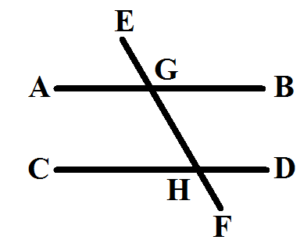
Attempt all questions.
Group ‘A’ [10x1=10]
1. a) In the given figure, which is the alternate angle of
$∡$BGH?
b) If the radius of the circular pond is 70m, find its area.
2. a) If the universal set U = {a, e, i, o, u} and A = {i, o, u}, find the
complement of set A.
b) Rationalize the denominator $\frac{5}{\sqrt{12}}$ .
3. a) If C.P = Rs.100 and S.P = Rs.120, find profit percent.
b) If 40% of 680 students are boys, then find the number of girls.
4. a) Find the mean value of the following: 5, 11, 14, 10, 8, 6
b) If the sum of 10 numbers is 60, then find the mean.
5. a) Write the degree of the expression: x²+y²+z²-3xyz
b) What is the value of (x+2)⁰ ?
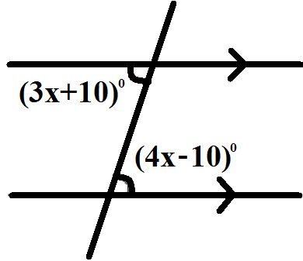
Group ‘B’ [17x2=34]
6. a) Find the value of x from the given figure.

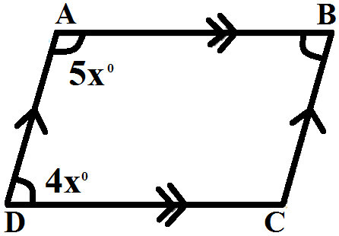

b) Find the unknown sizes of angles in the
following figure.

c) Construct a regular hexagon having 5cm side by finding interior angles.
7. a) Find the distance between the points A (7, 4) and B (6, 8).
b) The perimeter of a square is 40cm. find the area of the square.

c) A cuboid has volume 960cm³. If the length and breadth of the cuboid are 12cm and 10cm respectively, what is the height?

8. 8. a) If U = {0, 1, 2, 3, 4, 5, 6, 7, 8, 9}, A = {1, 3, 5, 7, 9} and B={1, 2, 3, 4,
`
b) Convert 11111₂ into decimal number.
c) Simplify: 1110₂ – 101₂ + 110₂
9. a) The cost of 5 kg of rice is Rs.400.
i) Find the cost of 1 kg of rice and 12 kg of rice.
ii) How many kilograms of rice can be bought for Rs.240?
b) Two numbers are in the ratio 3:2 and their difference is 52. Find the
numbers.
c) What is the sum whose 20% is Rs.400?
10. a) If mean $\overline{X}$=9,$∑$x=80+p and N=10, find the value of p.
b) If mean of 2, 5, 7, x+3, 9, 10 is 8, find the value of x.
c) Factorize: 125+$\frac{1}{x^{3}}$ .
11. a) Find the value of: 4x²-16=0.
b) Simplify: $\frac{\sqrt{27}+\sqrt{48}}{7}$ .
Group ‘C’ [14x4=56]
12. In a survey of 100 people, it was found that 65 liked folk songs, 55 liked
modern songs and 35 liked folk as well as modern songs;
a) Draw the Venn-diagram to illustrate the fact.
b) How many people did not like both songs?
13. A retailer buys 30 articles at Rs.8 each. Three are damaged but he sells
the rest at Rs.10 each. What is the profit percent?
14. The ratio of the present age of a father and his son is 3:1. Five years hence,
the ratio of their age will be 5:2. Find their present ages.
15. Sahayata spends 30% of her income on food, 15% on rent and 5% on
other items in a month. If she saves Rs.15,500 in a month, find her
monthly income and expenditures on each item.

Date: 2079-09-19 10:00am

16. If the mean of the following data is 21, find the value of p.
x | 10 | 15 | p | 25 | 30
f | 3 | 5 | 2 | 5 | 5
17. If p + $\frac{1}{7}=7$, then find the value of p³+$\frac{1}{P^{3}}$ and p²+$\frac{1}{P^{2}}$ .

18. Find the H.C.F. of: x²+5x+6, x²+x-6 and x²-9 .
19. Simplify: $\sqrt{72}$ - $\frac{45}{\sqrt{50}}$ - $\frac{44}{\sqrt{128}}$ +2$\sqrt{98}$ .

20. Simplify: $\frac{x+1}{x^{2}+2x+1}$ + $\frac{x-1}{x^{2}-2x+1}$
21. Find the volume of given solid.

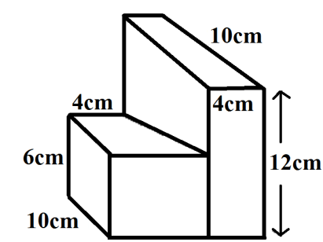

22. The length of a cuboid is thrice the breadth and twice the height. If the
volume of the box is 2304 cm³, then find the dimensions of the box.
23. In the adjoining figure, show that ∡x+∡y+∡z=180$°$.
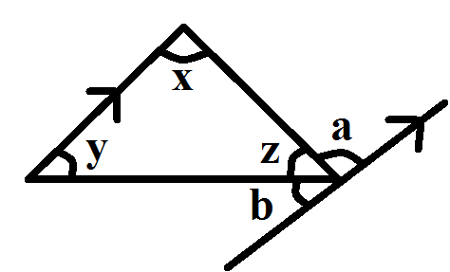

24. Find the value of x, y, z and w from the given figure.
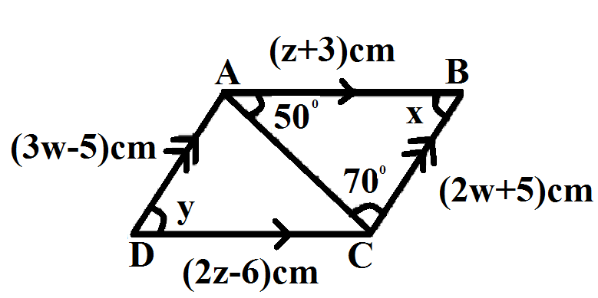

25. Verify experimentally that the opposite sides of a parallelogram are equal
to each other.

Sarbanam Shikshyalaya
Gokarneshwor-06, Jorpati, Kathmandu
Third Terminal Examination-2079
Class: 8 F.M=25
Subject: Listening and Speaking P.M=10
Time:30min

Name: Class/Sec : Roll No:_______
- Choose and write the correct answer. (5x1=5)
  - The tall man stared at the writer furiously because........................... .. .
- The writer didn’t let him eat the biscuits
ii. There were no biscuits left in the packet
iii. The writer ate his biscuits
- The word ‘fuss’ means..................... .
- Unnecessary issue ii. quarrel
iii. Joke
- The word ‘pretending' means.......... .
- Acting correctly
ii. Behaving as if something is true
iii. Doing wrong things
- The word ‘furiously’ means............ .
- Surprisingly
ii. Angrily
iii. Happily
- The narrator.............. the newspaper and hoisted up.
- Opened
ii. Crumpled
iii. Tore
- Write True or False. (5x1=5)
  - The writer was able to catch the train. __________
  - The writer was nervous. __________
  - He bought a magazine and tea. __________
  - He was very tall. __________
  - His packets of biscuits was actually unopened. __________
- Regularity (3)
- Handwriting (3)
- Oral (3)
- Discipline (3)
- Assignment (3)
Sarbanam Shikshyalaya
Gokarneshwor-06, Jorpati, Kathmandu
Third Terminal Examination-2079
Class: 8 F.M=25
Subject: Listening and Speaking P.M=10
Time:30min

Name: Class/Sec : Roll No:_______
- Choose and write the correct answer. (5x1=5)
  - The tall man stared at the writer furiously because........................... .. .
- The writer didn’t let him eat the biscuits
ii. There were no biscuits left in the packet
iii. The writer ate his biscuits
- The word ‘fuss’ means..................... .
- Unnecessary issue ii. quarrel
iii. Joke
- The word ‘pretending' means.......... .
- Acting correctly
ii. Behaving as if something is true
iii. Doing wrong things
d. The word ‘furiously’ means............ .
- Surprisingly
ii. Angrily
iii. Happily
- The narrator.............. the newspaper and hoisted up.
- Opened
ii. Crumpled
iii. Tore
- Write True or False. (5x1=5)
- The writer was able to catch the train. __________
- The writer was nervous. __________
- He bought a magazine and tea. __________
- He was very tall. __________
- His packets of biscuits was actually unopened. __________
- Regularity (3)
- Handwriting (3)
- Oral (3)
- Discipline (3)
- Assignment (3)
Sarbanam Shikshyalaya
Gokarneshwor-06, Jorpati, Kathmandu
Third Terminal Examination-2079
Class: 8 F.M=100
Subject: O. Math P.M=40
Time:3 hrs
Attempt all the questions:
Group’A’ [8x1=8]
- (a) What are unlike surds?
(b) `What is Pythagoras theorem?
(c) Write section formula of internal section.
(d) Define transpose of matrix with example.
- (a) Define unit vector with example.
(b) What is rotation?
(c) What is statistics?
(d) Find the value of ‘x’
4cm

3cm
Group’B’ [9x2=18]
- (a) Convert $\sqrt[4]{243}$ into a mixed surd.
(b) Prove that: cos²$θ$xtan$θ$xsec$θ$=sin$θ$
(c) Find the distance of point C(2,$\sqrt{21}$) from origin.
- (a) If A=$\left[\begin{matrix}3 & 4 \\ 6 & 10\end{matrix}\right]$, B=$\left[\begin{matrix}1 & 2 \\ 5 & 9\end{matrix}\right]$ Find (A-B)^{T}.
(b) Find magnitude of the vector $\vec{a}$=$\left({6 \atop 8}\right)$.
(c) Find the image of point A(3,5) under reflection on x-axis and y-axis.
- (a) Find the arithmetic mean of 20, 18, 32, 40,44.
(b) Find the median from 6,8,11,7,18,15,13.
(c) Find ratio of sin$θ$ if tan$θ$⁼$\frac{5}{12}$.

Group’C’ (16x4=64)
- Find AXB and BXA if A=$\left\{1,2,3,4\right\}$ and B=$\left\{5,7,8\right\}$.
- One angle of a right angled triangle is 60$°$. Find the other in grade.
- Prove that: $\sqrt{\frac{1+SinA}{1-SinA}}$ = $\frac{1+SinA}{CosA}$ = secA+tanA
- Rationalize: $\frac{\sqrt{7}+\sqrt{5}}{\sqrt{7}-\sqrt{5}}$ .
- If $\sqrt{a^{2}+b^{2}}$ .cos$θ$ =b, show that btan$θ$=a.
- (aSin$θ$-bCos$θ$)²+(aCos$θ$+bSin$θ$)²=a²+b².
- From the given figure, find all the trigonometric ratios: 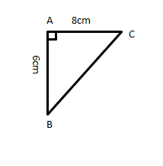
- Find the coordinate of point which divides the line segment AB in the given ratio internally A(1,1) and B(4,4); ratio=1:2
- Show that the given vertices of isosceles triangle parts are A(2,1), B(2,3), C(4,2).
- If 2$\left[\begin{matrix}3 & 4 \\ 5 & k\end{matrix}\right]$+$\left[\begin{matrix}1 & y \\ 0 & 1\end{matrix}\right]$=$\left[\begin{matrix}7 & 0 \\ 10 & 5\end{matrix}\right]$, find x and y.
- Prove that the vector$\vec{a}$ =$\left({\frac{5}{13} \atop \frac{12}{13}}\right)$is unit vector.
- A(2,3), B(4,5) and C(6,2) are the vertices of $∆$ABC. Represent $∆$ABC in graph and rotate $∆$ABC by 90$°$ in clockwise direction about the origin and write the coordinate of image formed.
- Find the mean from the following data :
X | 4 | 12 | 20 | 28 | 36
f | 5 | 9 | 10 | 8 | 8

- If the median of the following data is 70, find the value of x.
50, 60, $\frac{3x+5}{2}$ , 50, 90
- If $\vec{a}$ $= 4\vec{i}+3\vec{j}$ and $\vec{b}$=6$\vec{i}$-$\vec{j}$, find
- $\vec{a}$+$\vec{b}$
- Magnitude of $\vec{a}+\vec{b}$
- Direction of $\vec{a}+\vec{b}$
- Unit vector along $\vec{a}+\vec{b}$
- Arrange the following curds in ascending order: $\sqrt[4]{6}$, $\sqrt[3]{5}$ and $\sqrt{2}$.
- If A=$\left[\begin{matrix}3 & -4 & 6 \\ 7 & 2 & 5 \\ 1 & 9 & 8\end{matrix}\right]$, then find A^{T} , (A^{T})^{T}, A^{T}-2A
- Class Test [10]

